**ECEN 325 Lab 1: First Order Circuits**

Faizan Bangash

Section 504

09-12-2018

**Calculations-**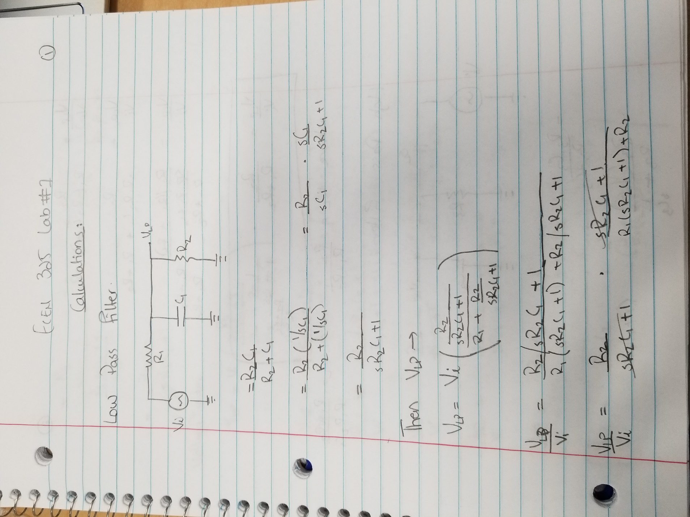

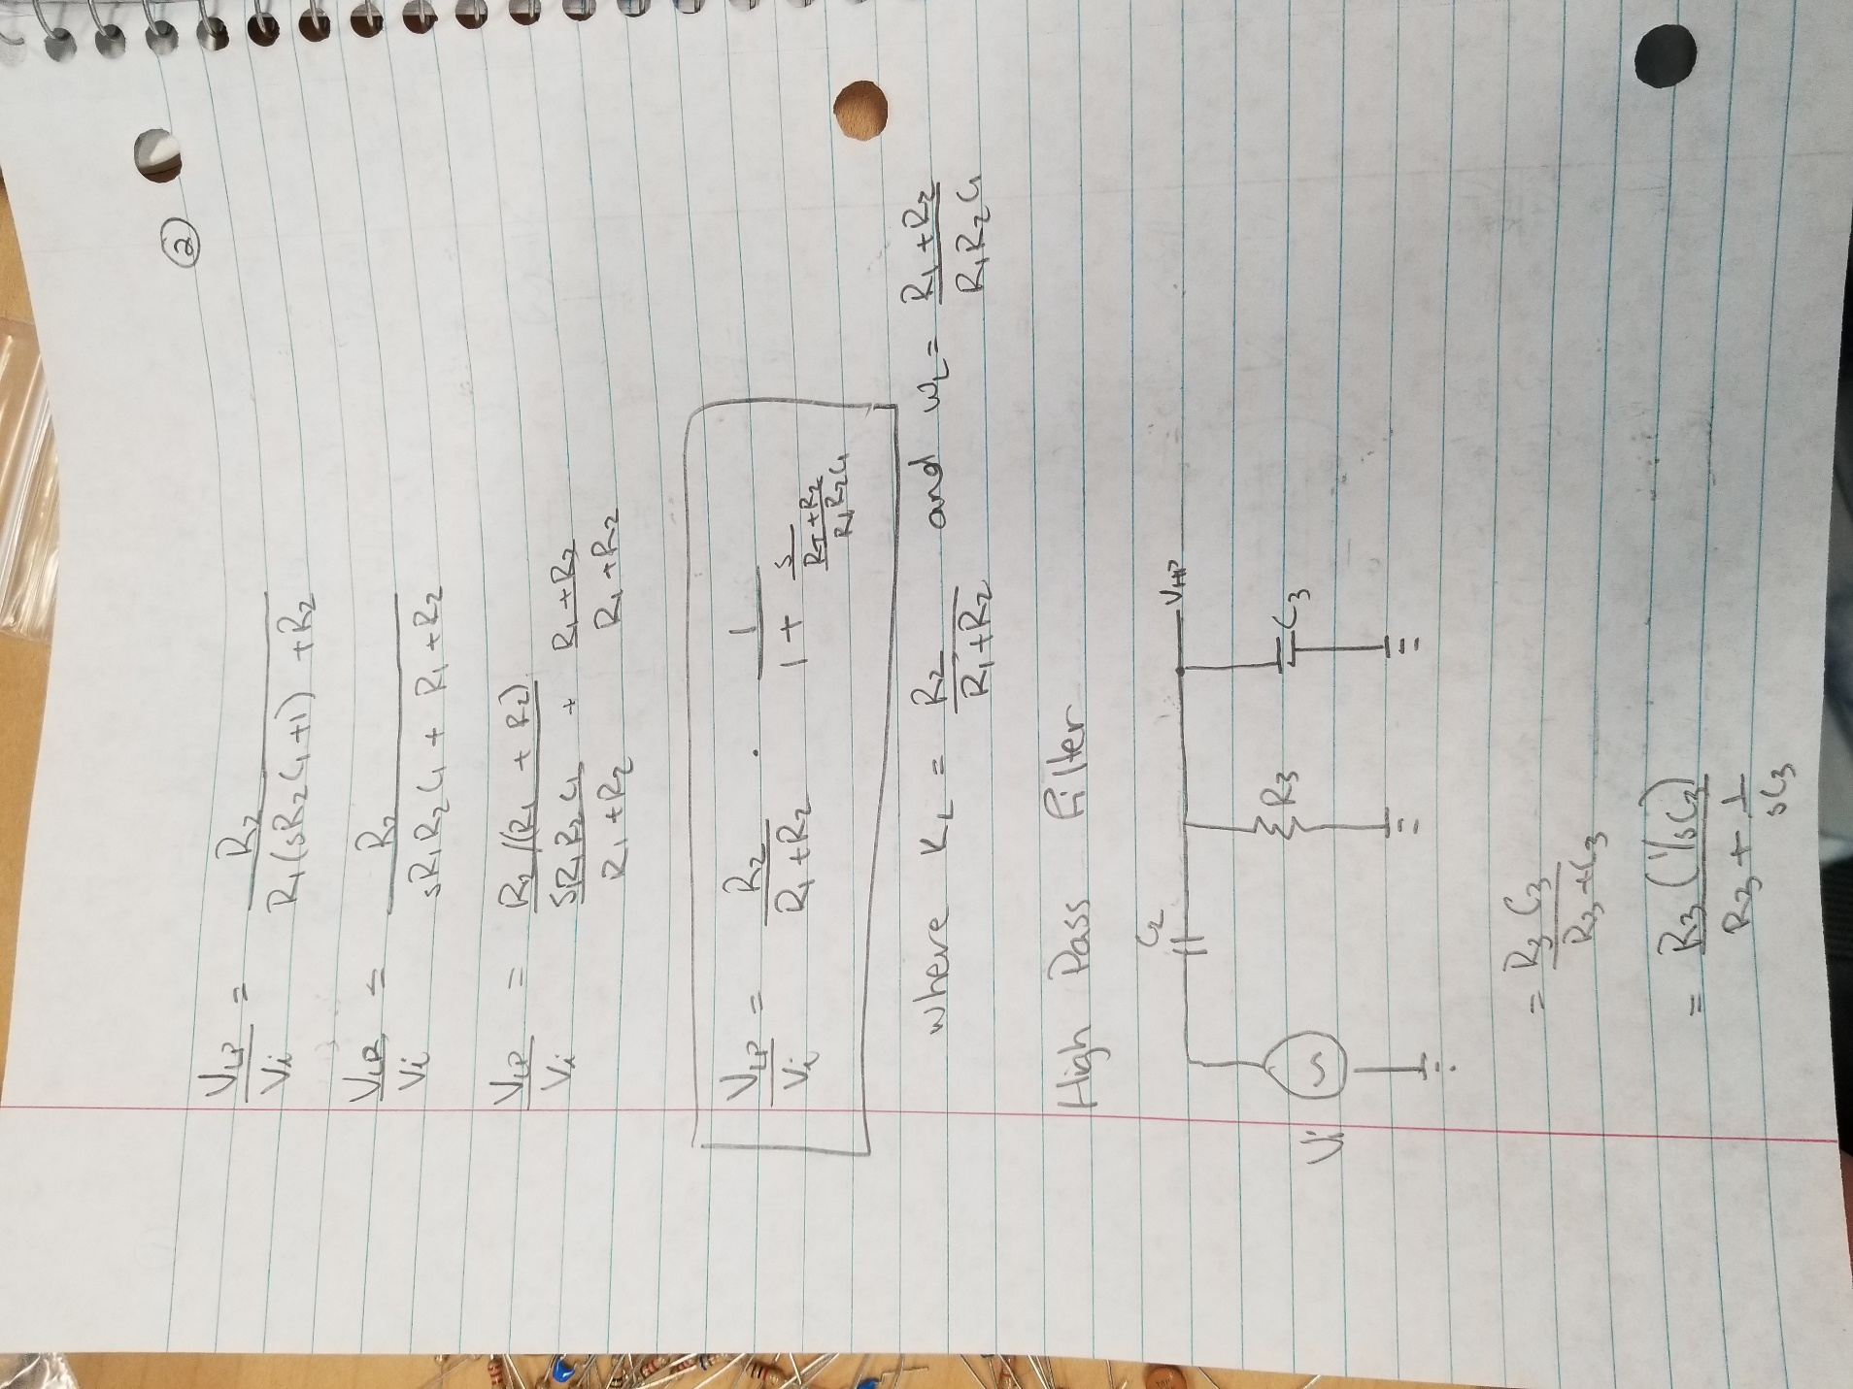

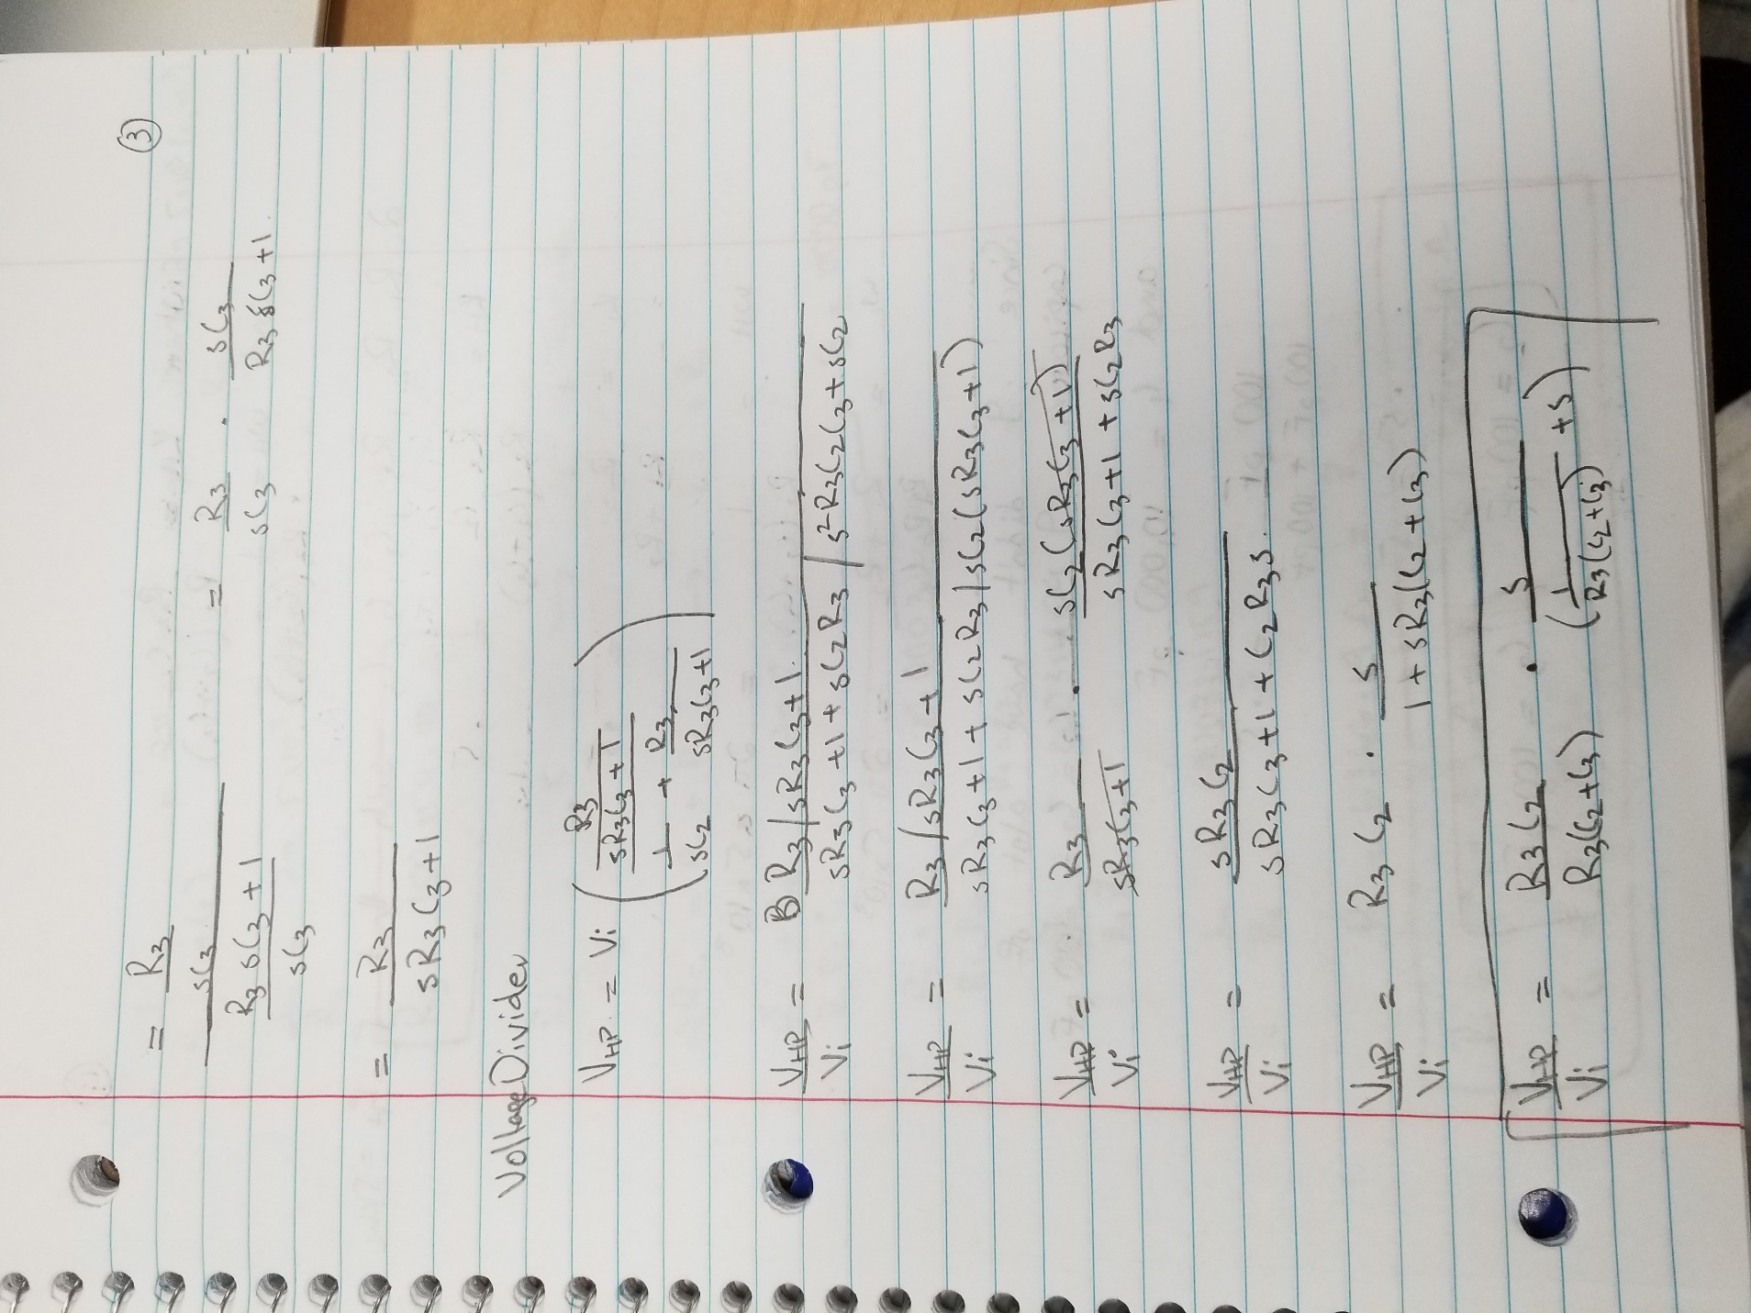

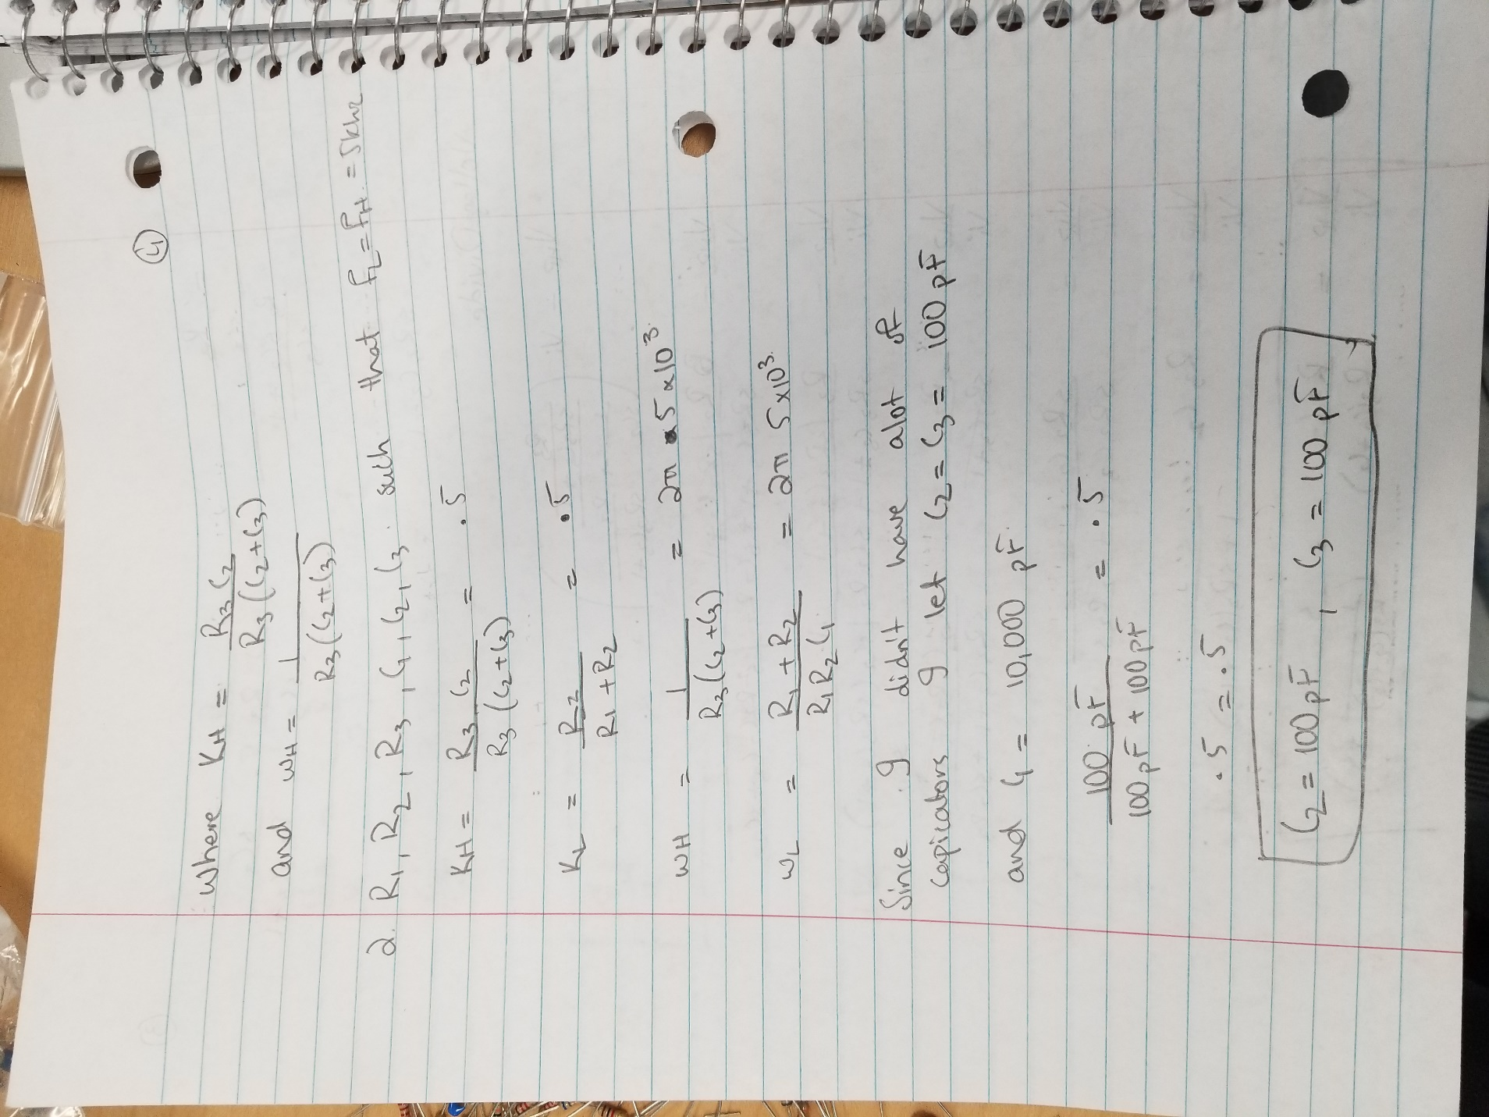

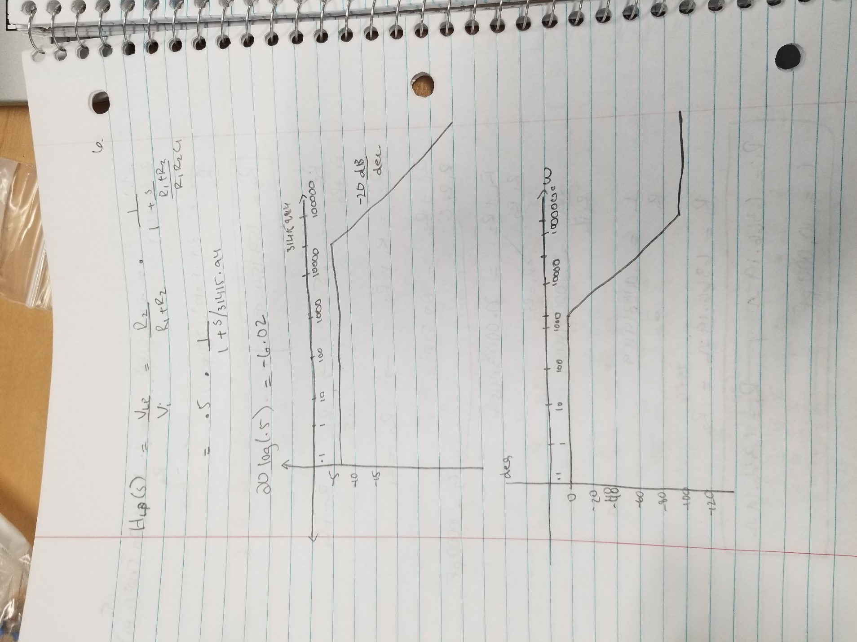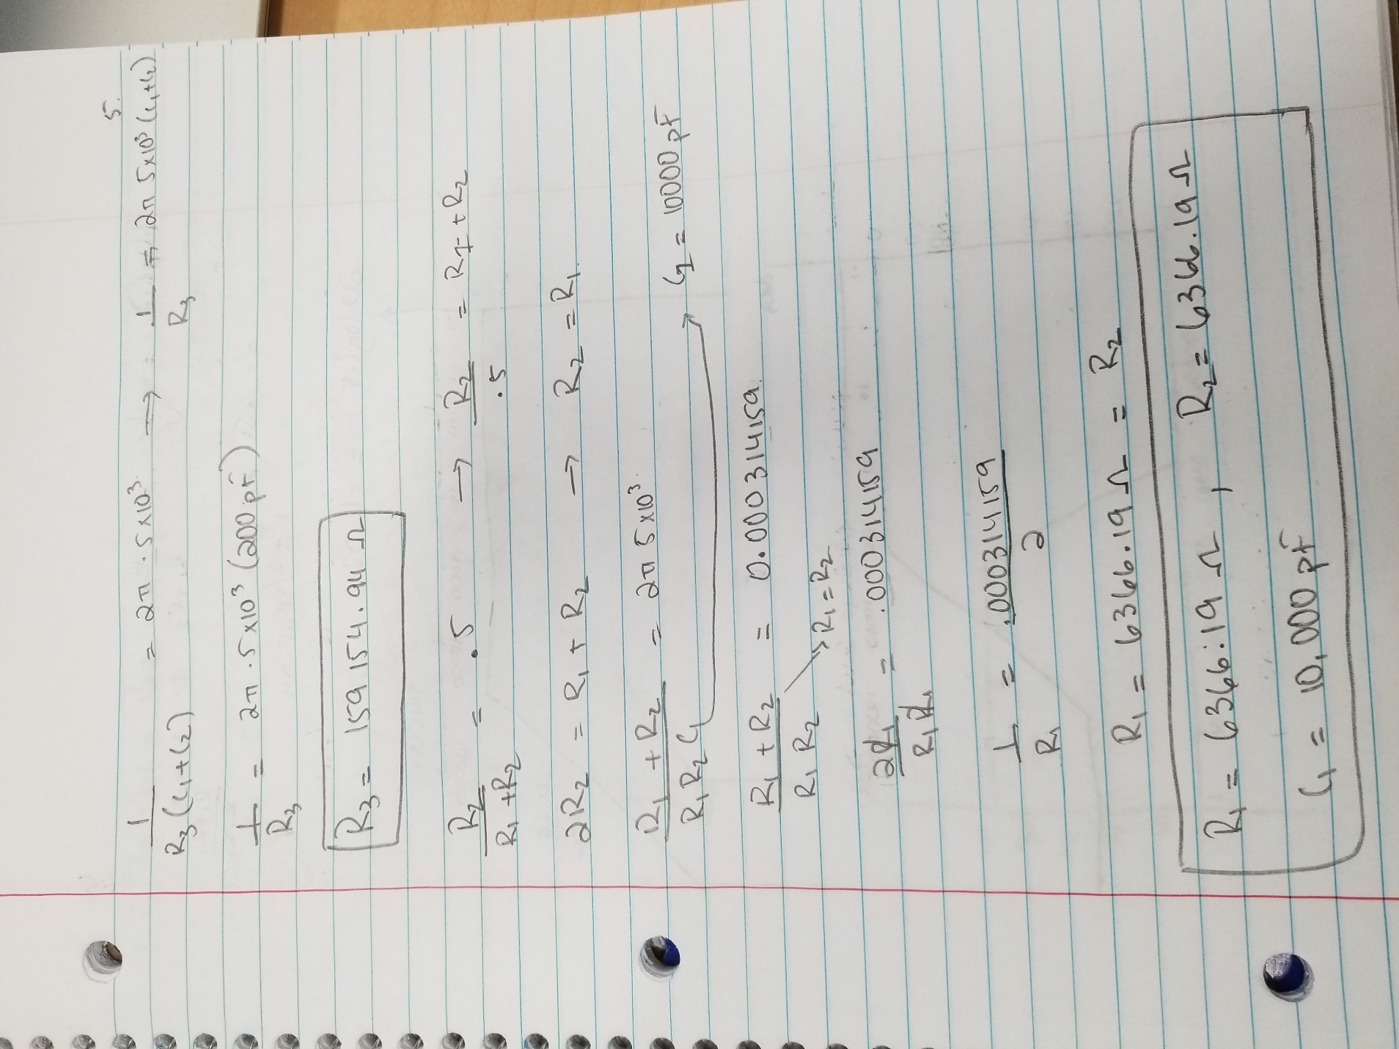

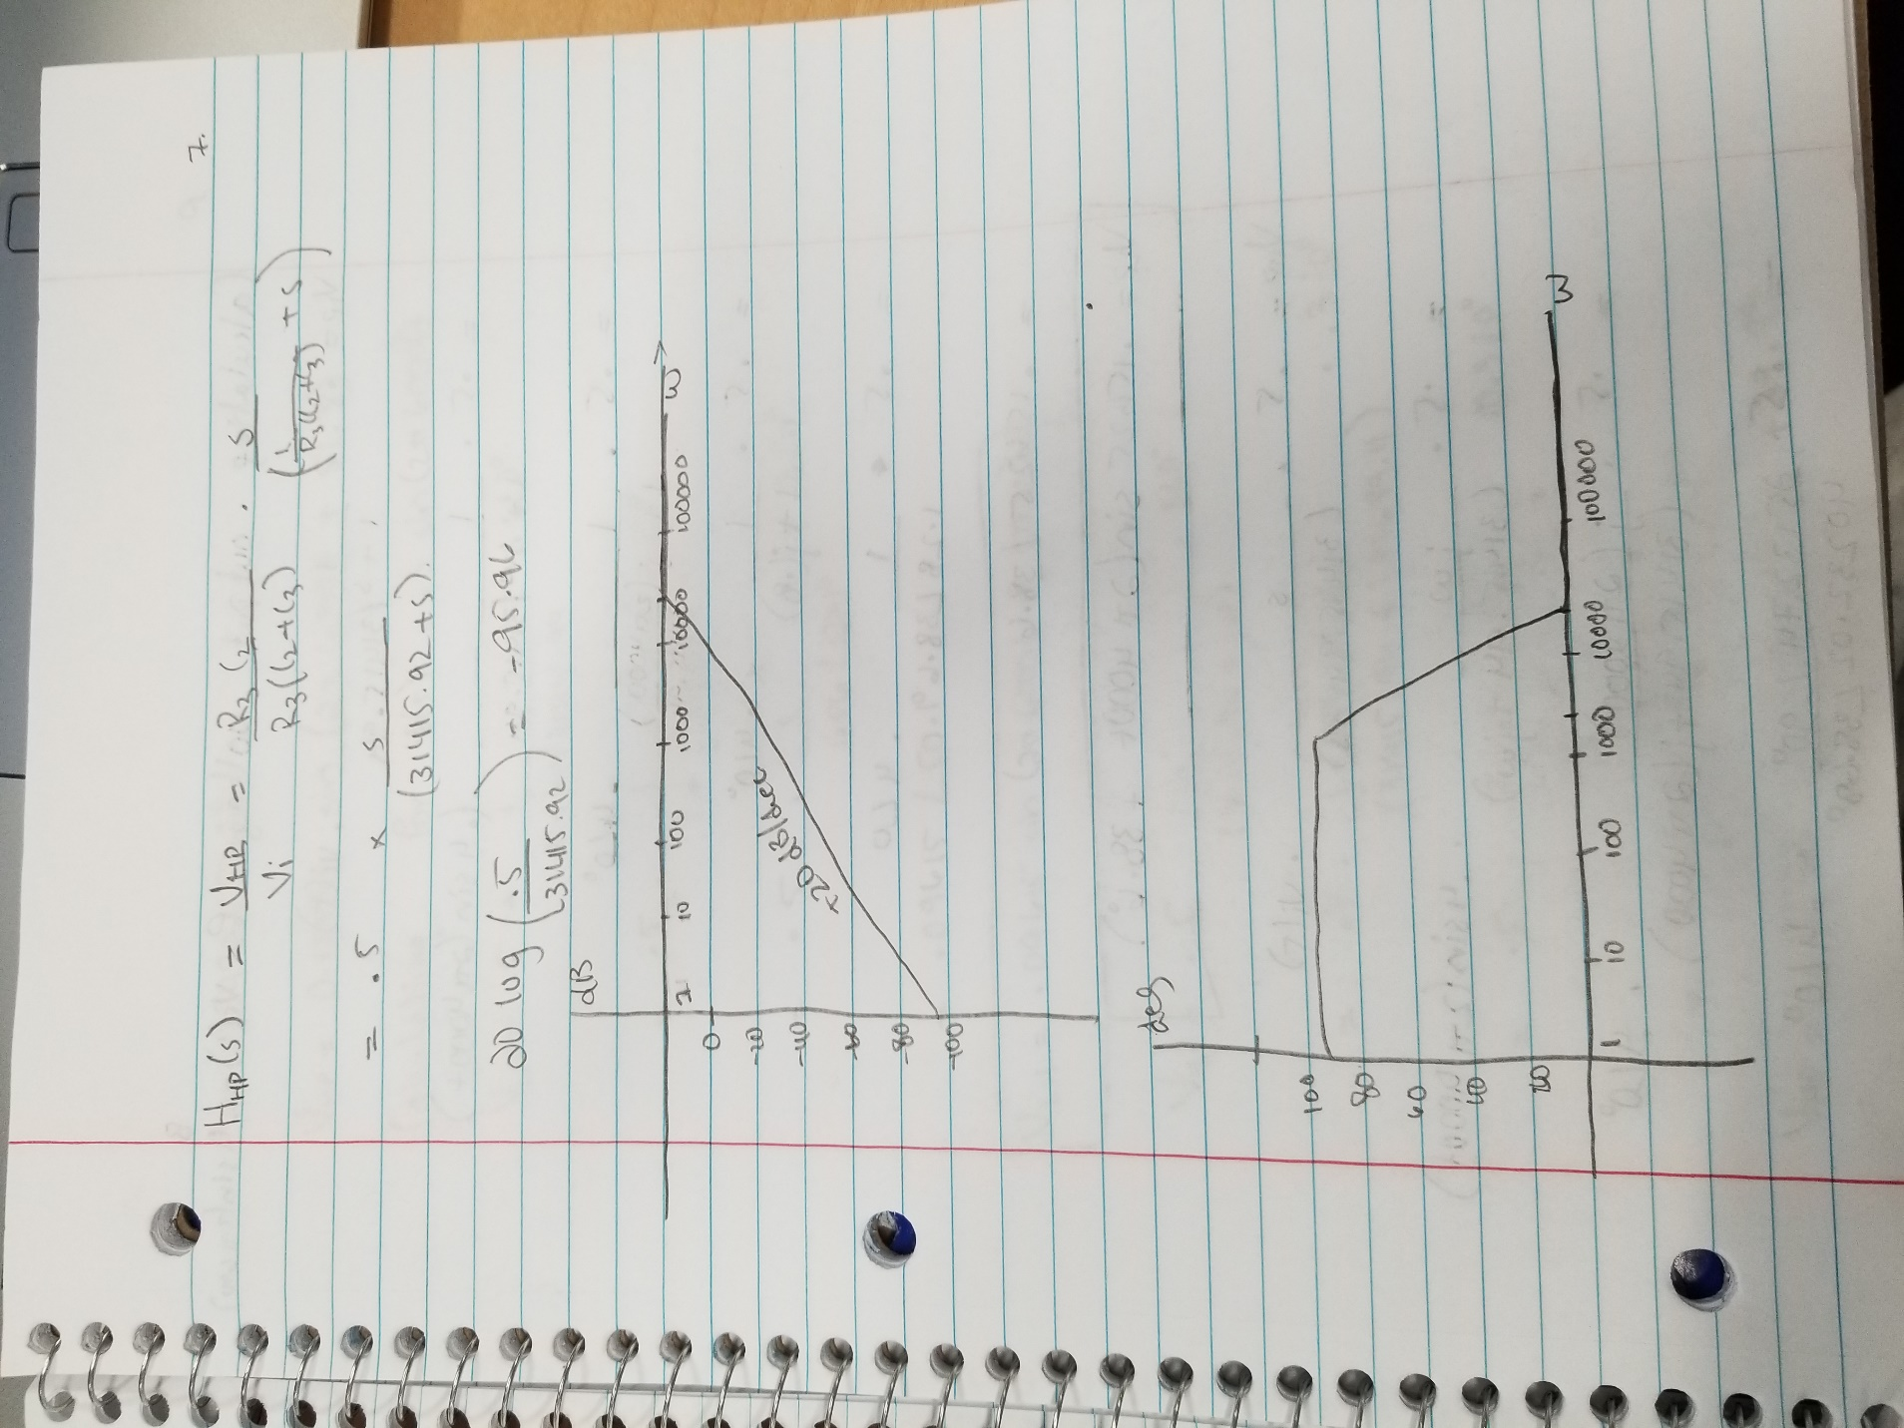

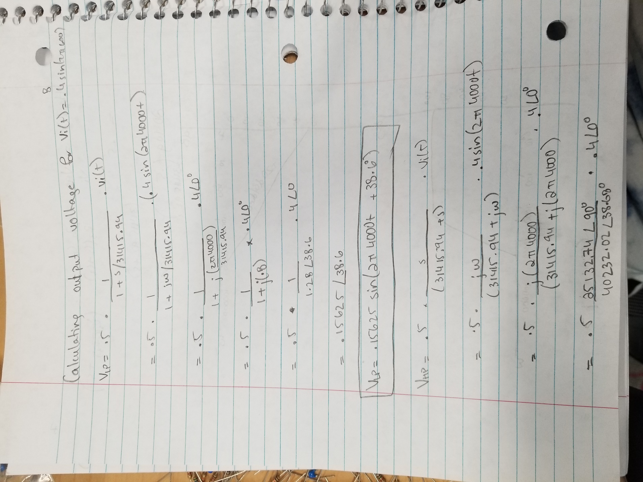

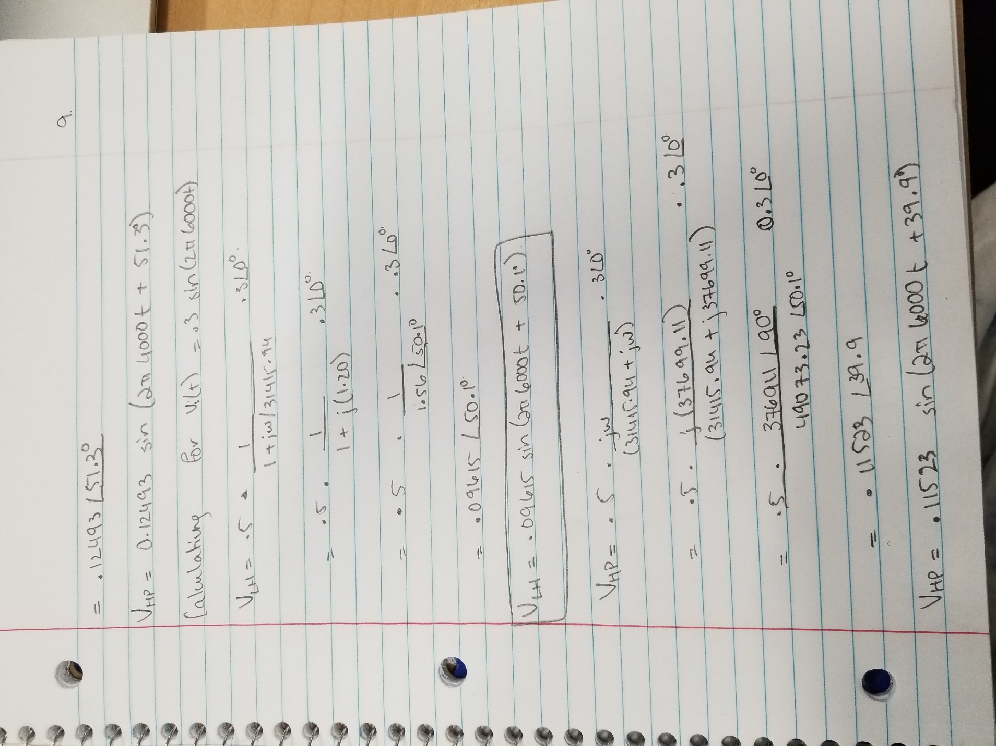

**Simulations –**

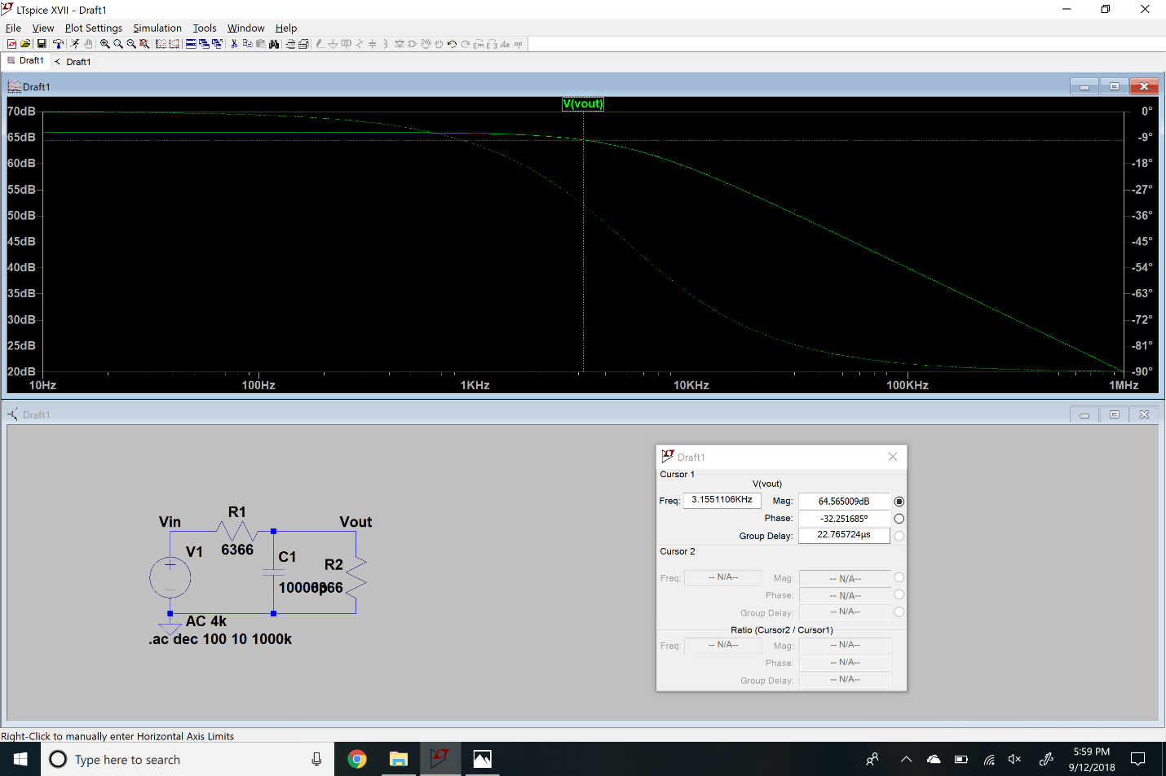

Low Pass 4kHz

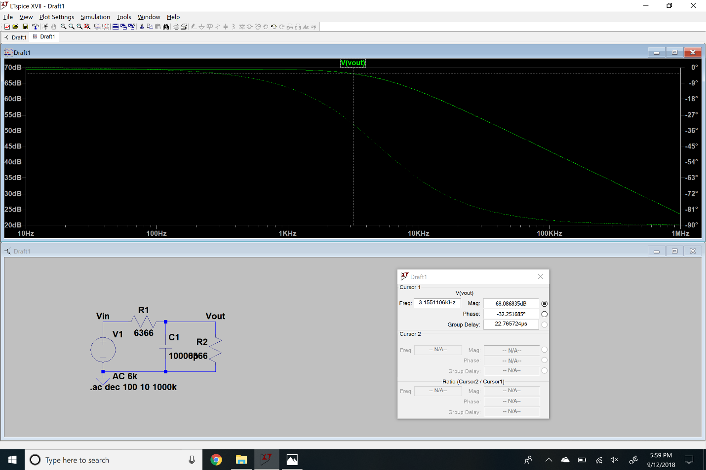

Low Pass 6kHz

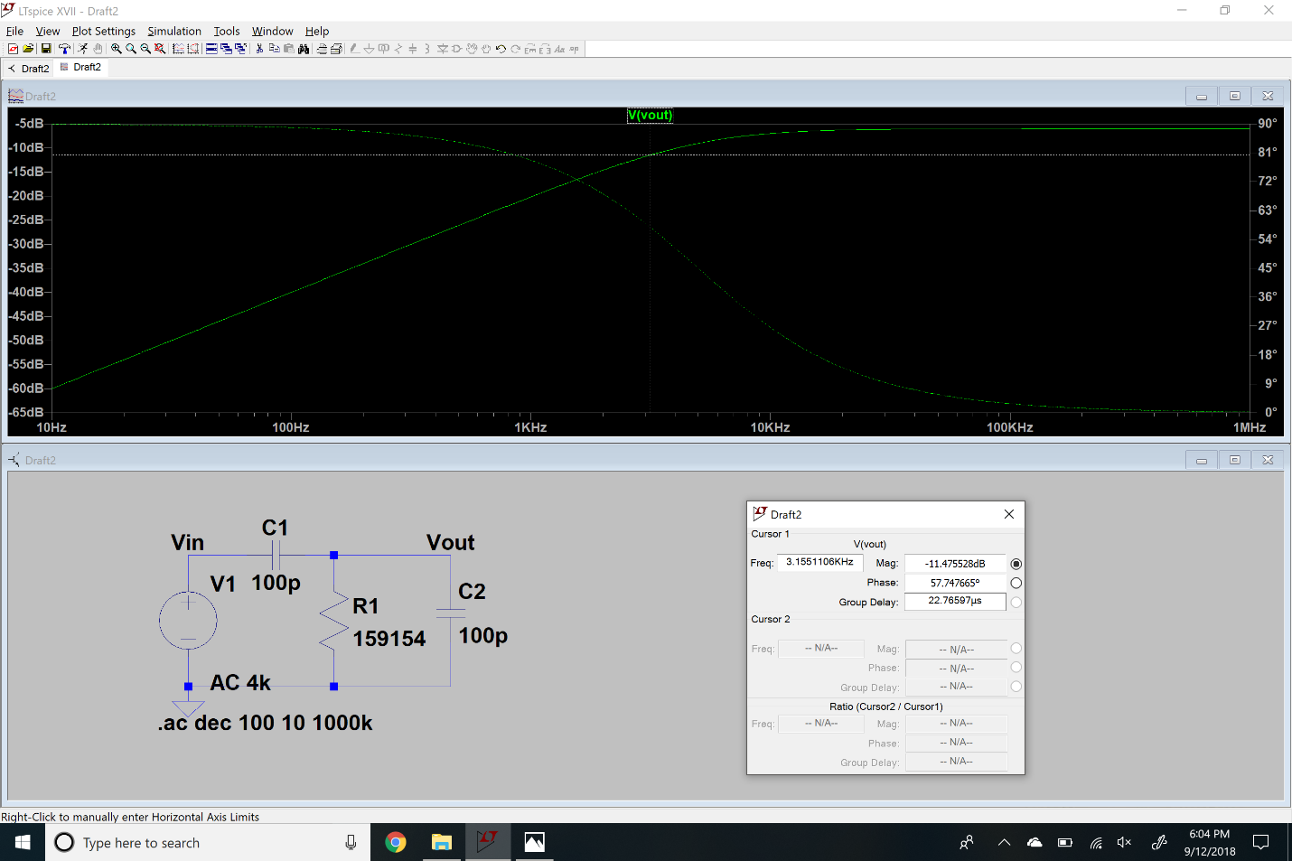

High Pass 4kHz

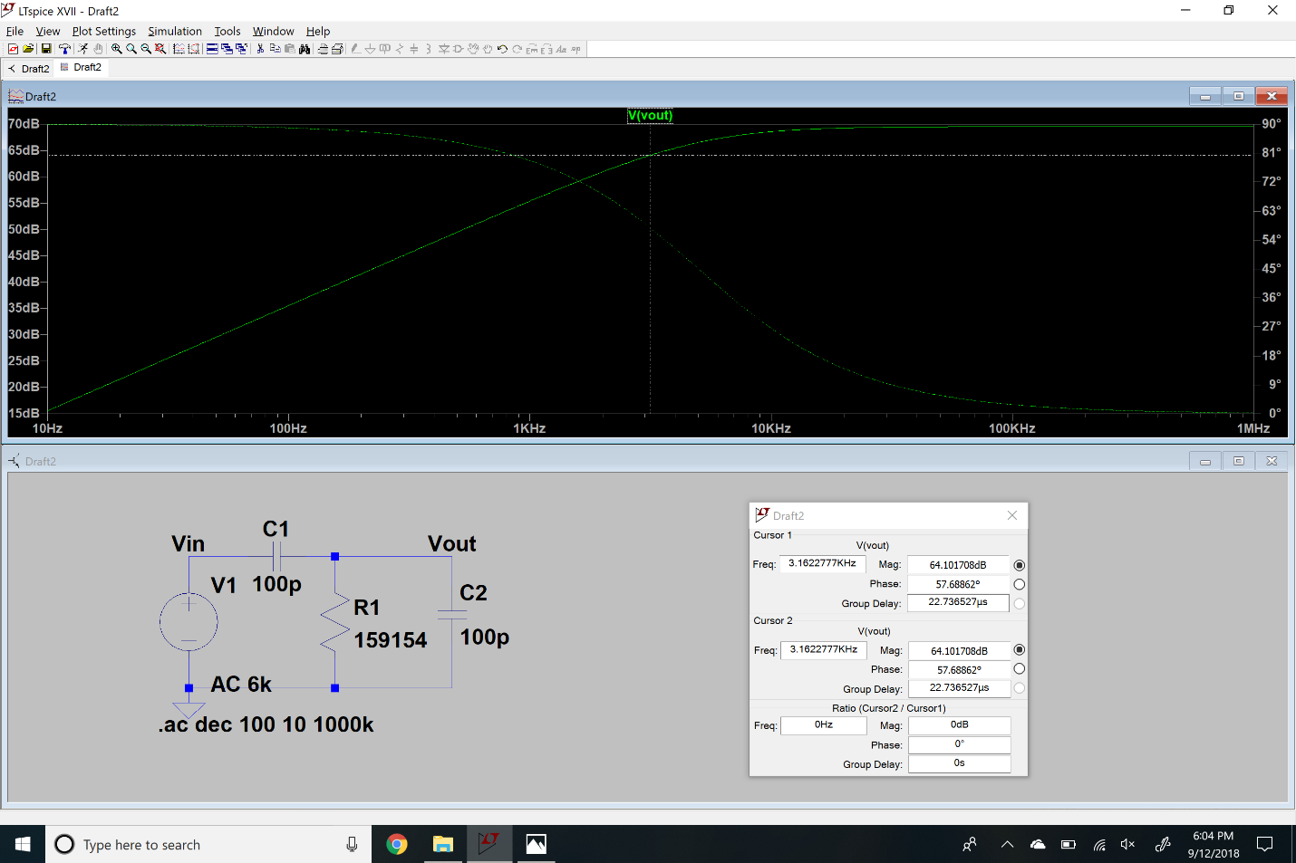

High Pass 4kHz

**Measurements –**

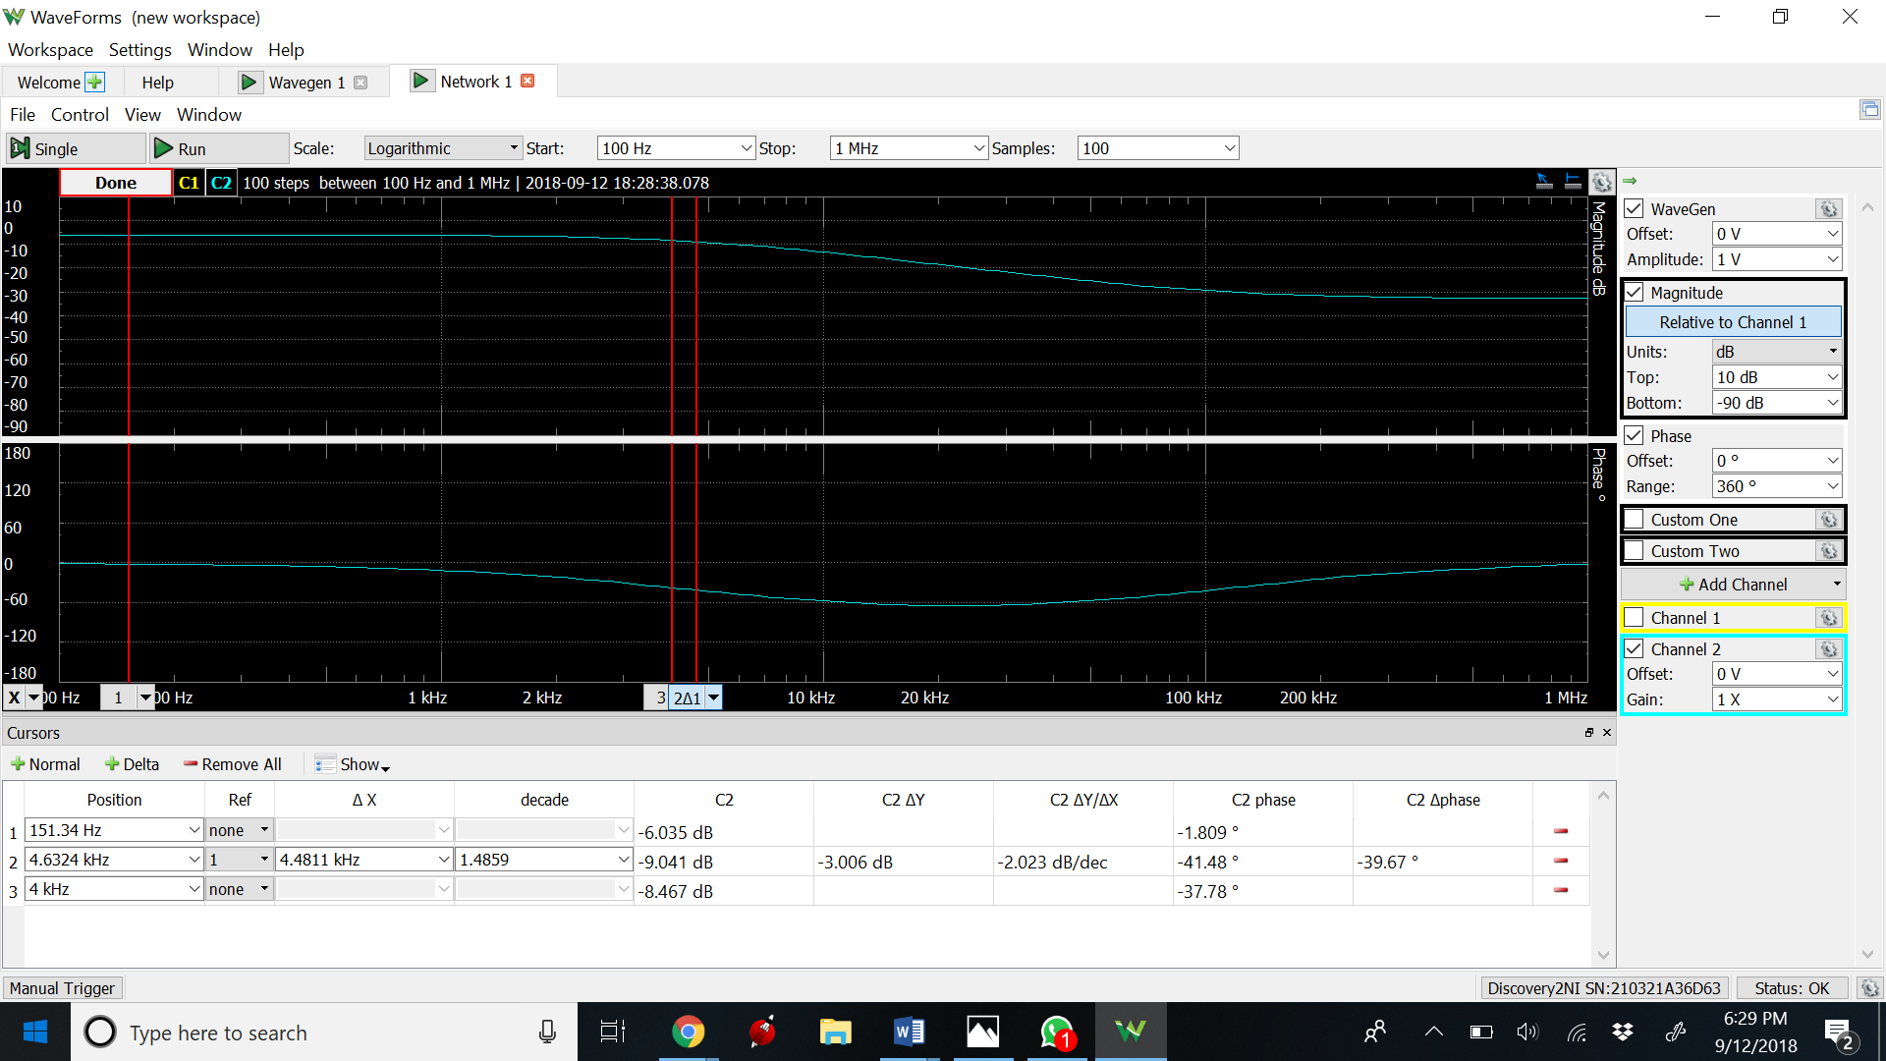

Low Pass 4khz Bode and Phase Plot

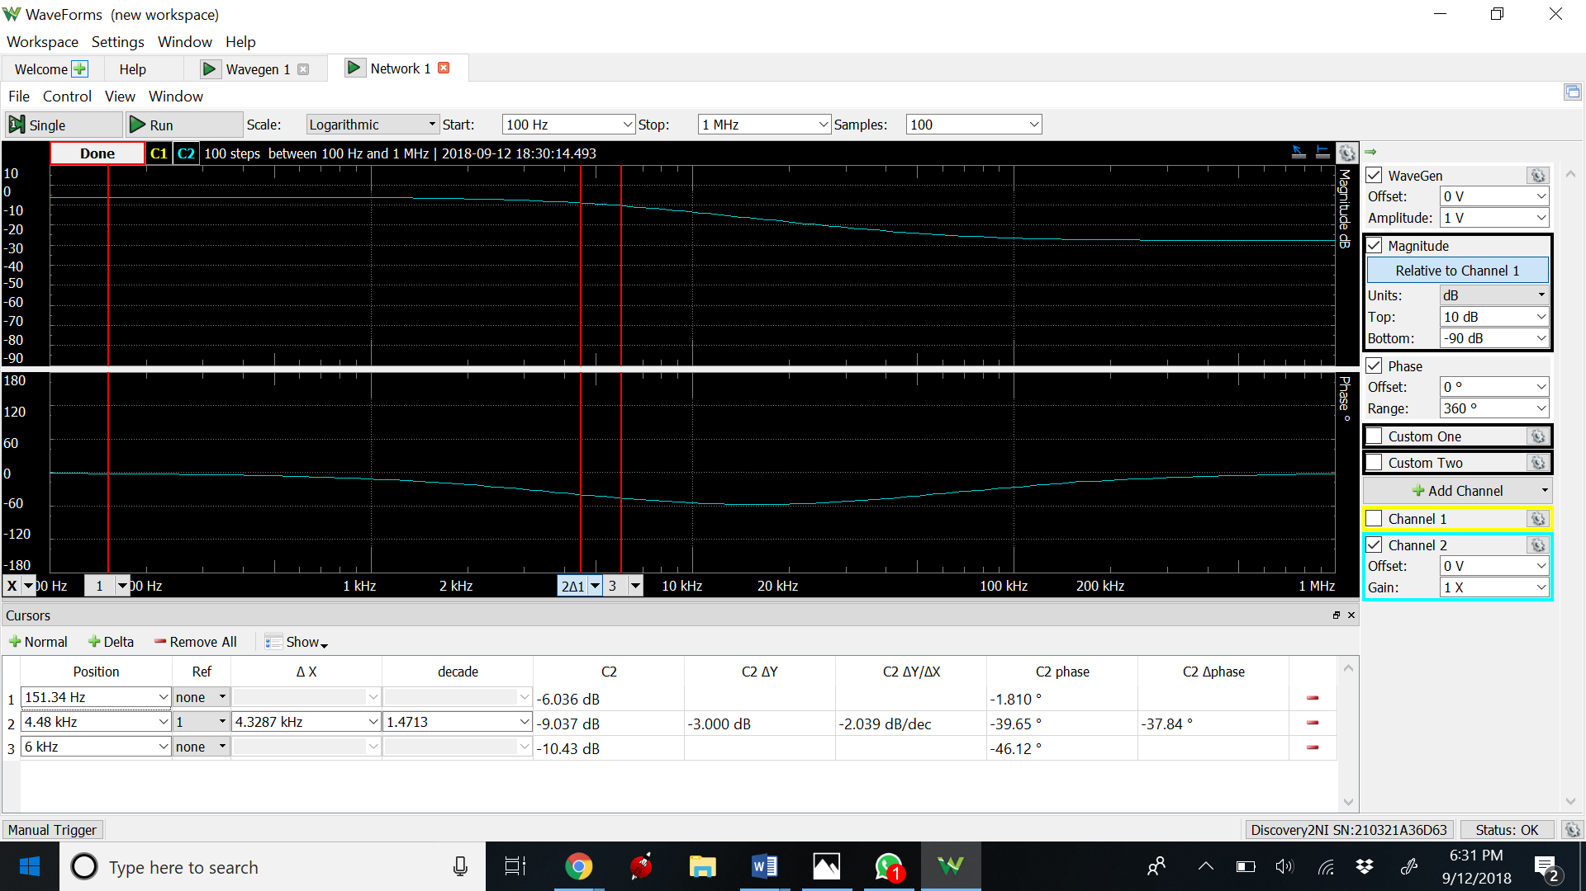

Low Pass Bode and Phase plot at 6khz

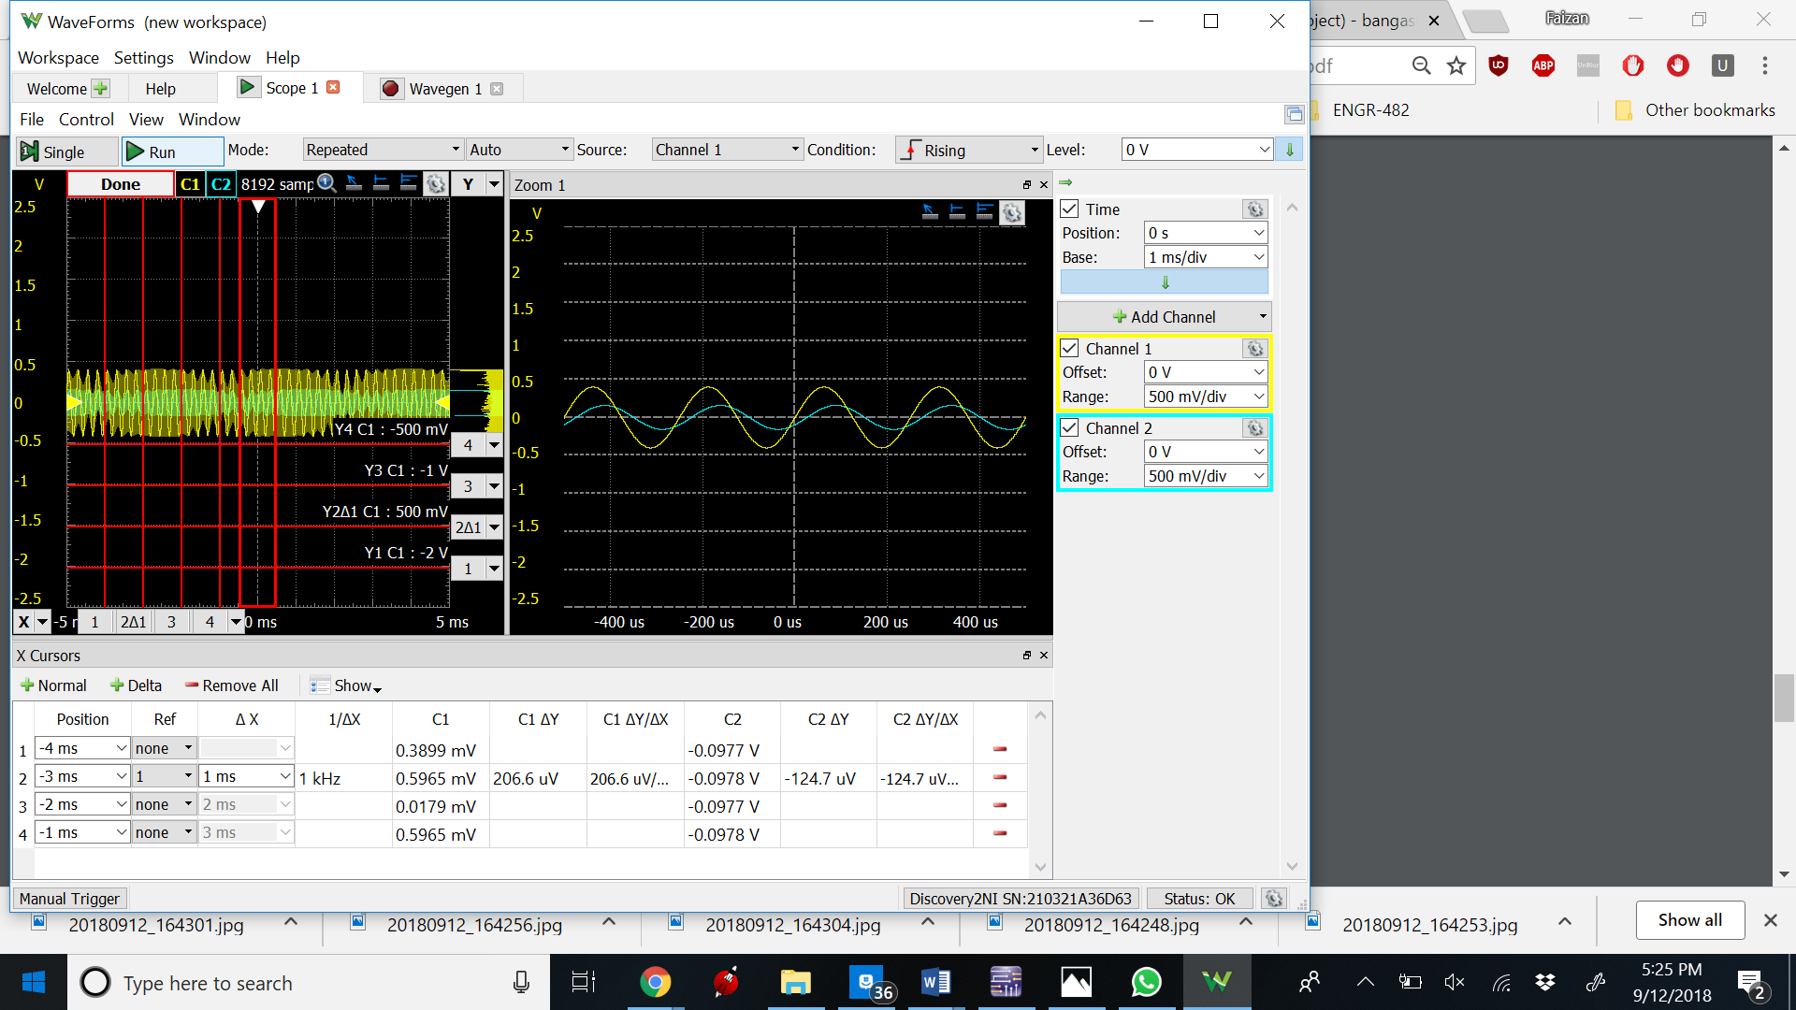

Low Pass Transient at 4000Hz

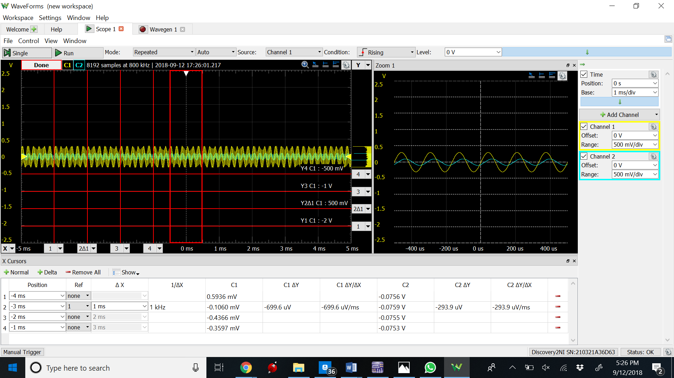

Low Pass Transient at 6000Hz

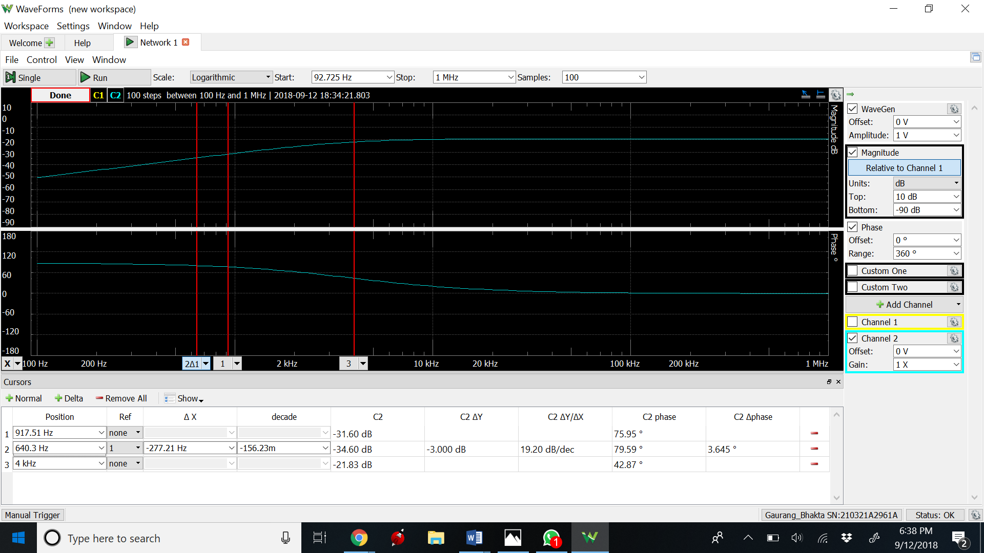

High Pass Bode and PhasePlot at 4kHz

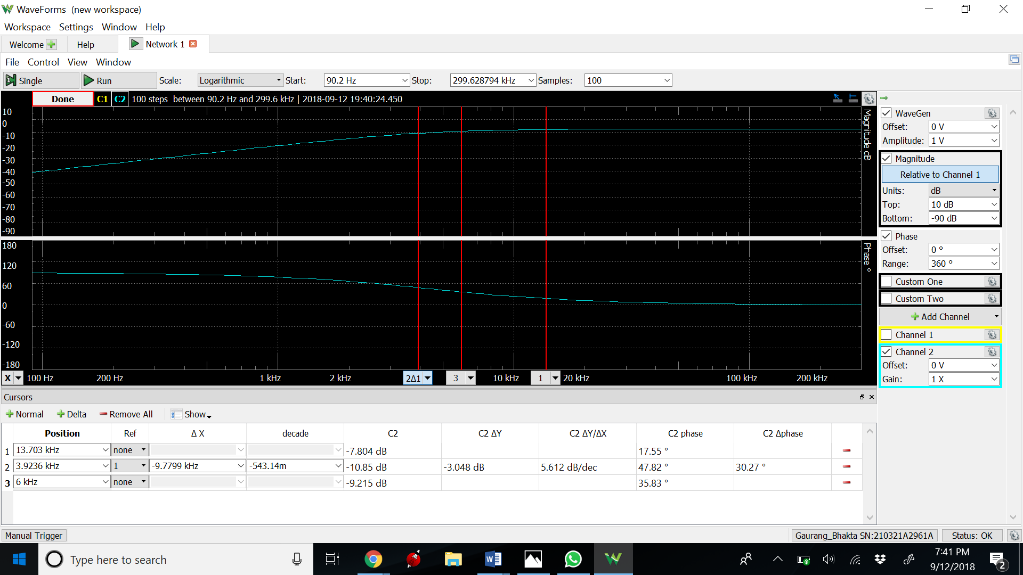

High Pass Bode and Phase plot at 6kHz

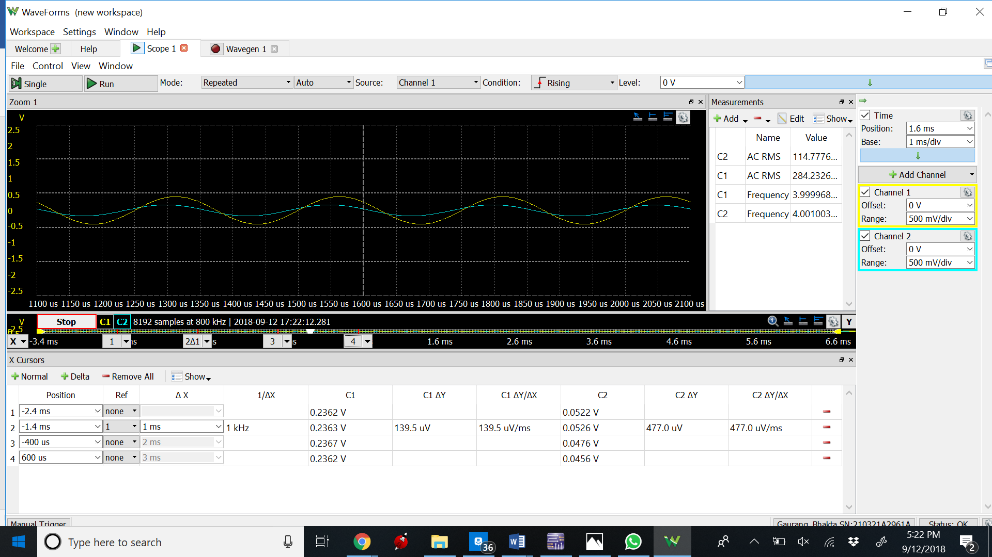

High Pass Transient at 4kHz

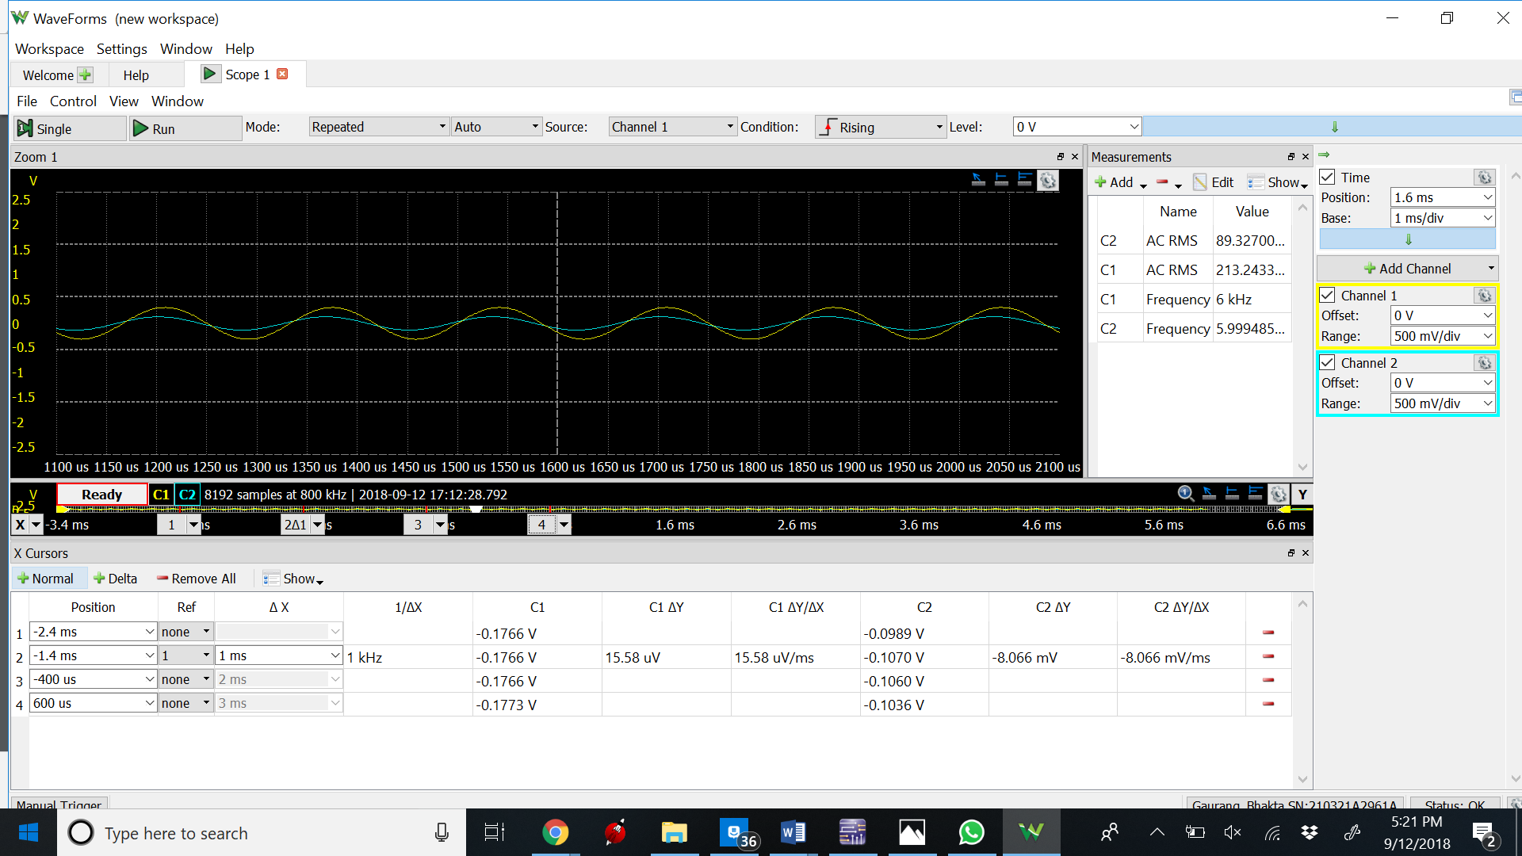

High Pass Transient at 6kHz

Conclusion –

For the Bode plots, for both the high and low pass circuits, the experimental values mostly matched the calculated simulated values. The variations in the values is probably due to extra resistances since we didn’t have the exact resistors or it could be due to unaccounted for variables it the wires or in the equipment used. However, the waveforms were close to the calculated waveforms and values from those waveforms. For the low pass filter waveforms of both frequencies and amplitudes, the experimental phase shift was completely different. The calculated phase shift for the low pass filter was 38.6 and 50.1 degrees for the 4 kHz and 6 kHz inputs respectively. The calculated phase shift for the low pass filter was 51.3 and 39.9 degrees for the 4 kHz and 6 kHz inputs respectively. The numbers I got on the experimental values very close to the numbers I calculated so the discrepancy is due to not having the exact resistor values. While the phase angles were close to the calculated values, the amplitudes of the output voltages were off for a couple of the plots.